**Comp1168 Lab5 –Physical Data Modeling and Forward Engineering**

**TUTORIAL**

1. **Please launch MySQL Workbench (login) and from the Home screen pick the modeling option.**

To get back to the Home button go to the farthest left side above the file menu

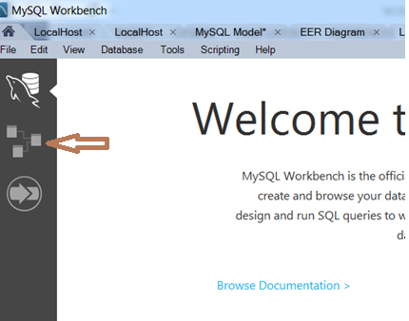

1. **Create a new Model**

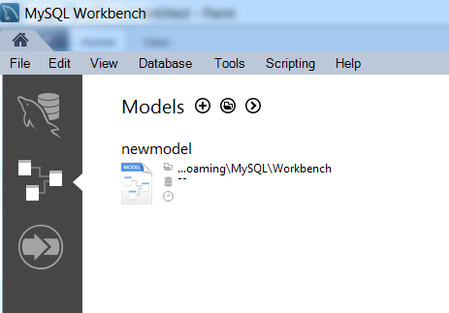

1. **Change the Default Schema Name**

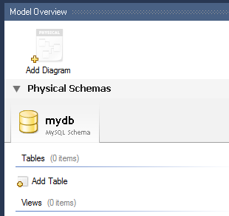

Click on **mydb** and in the bottom section change its name

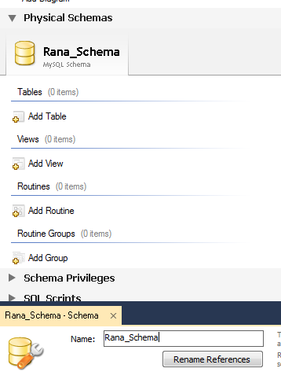

1. Add Tables

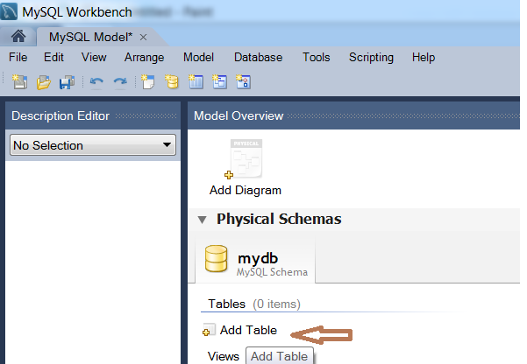

// add Customer and Order tables

1. **Add a new diagram and add the tables (drag and drop)to the diagram**

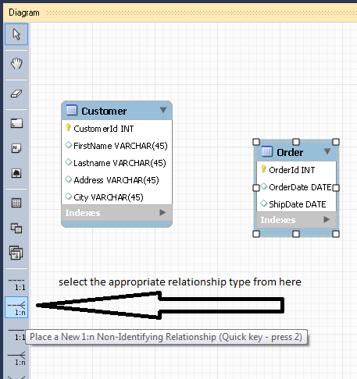

1. **Create a relationship between two tables**

Pick the appropriate relationship type from the tools bar (1:n- non identifying)

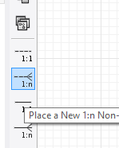

And touch the table on Many side (Order) first and then the table on the One side

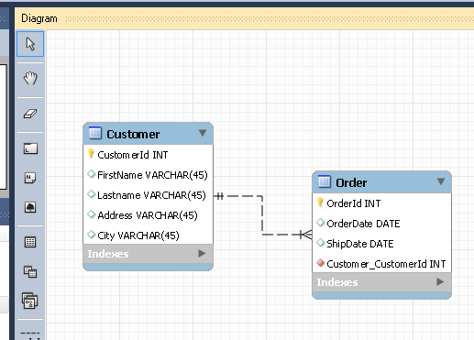

**Creating a 1: M relationship**

First of all make sure that there is a primary key in both tables (or at least on the table on “one” side of the relationship)

Click on the appropriate **relationship type tool** (1:M, M:N, identifying non identifying etc)

Please remember by default most 1:M relationships are **NON-IDENTIFYING**

Click on the **child table (Order) first** and then the **Parent table** (Customer)

Don’t add the **foreign key** (Customer_CustomerId) in order table, as it would be added automatically while creating the 1 to M relationship.

**[Click to expand to show the additional options, including M:M]**

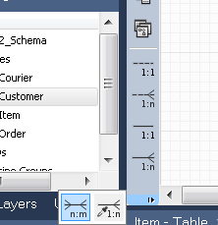

**Relationship Naming or captioning**

Name it **‘places’**

Double click the relationship line and click the first tab **“Relationship”**

By default ER diagram does not show relationship captions. You have to check the option.

**EDIT (Menu Item)-- Workbench Preferences---Modeling—Diagram---CHECK Show Captions Option.**

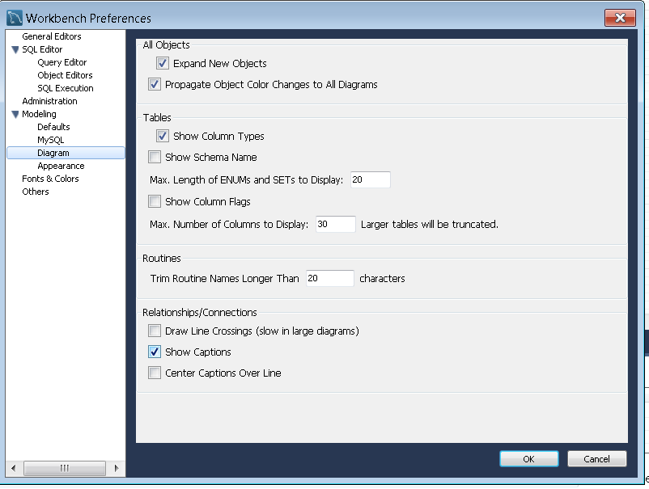

**Second Tab (Foreign Key)**

Double click on the relationship line to activate the properties and uncheck “Mandatory” box to change the cardinality on either side

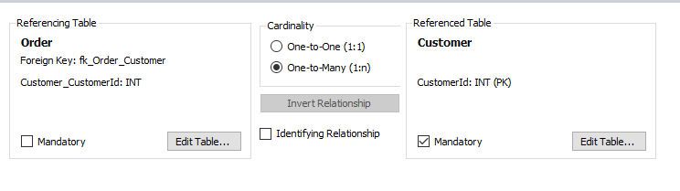

**Uncheck Mandatory from the Order side**

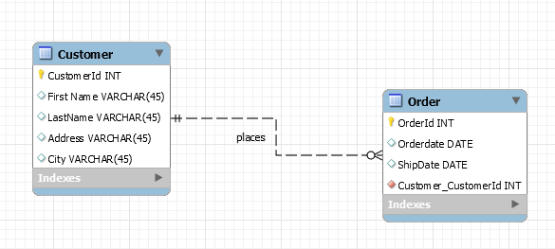

**Creating a Many to Many Relationship**

When u create an M:M, it will automatically add the **Linking Table** in between the two with a composite key consisting of both primary keys.

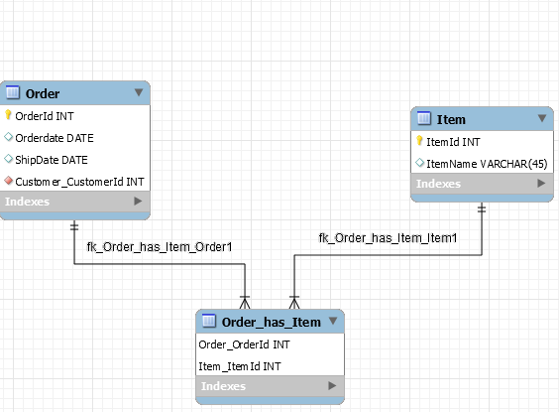

* Rename the Linking table to the M:M relationship name (“contains”)
* Delete the default captions for the relationships to the Linking table
* Adjust the minimum cardinalities.

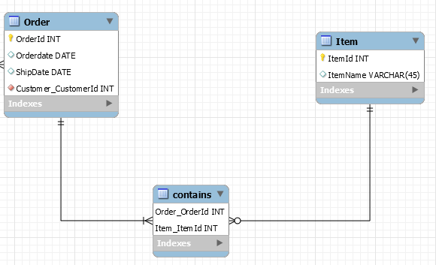

The final diagram looks like this:

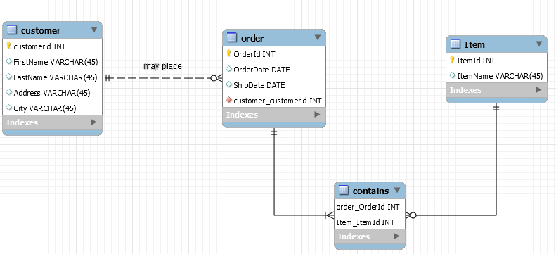

**Let us FORWARD ENGINEER this physical model:**

MySQL would first generate the script for creating the schema (Lab5) and the tables in this schema (Customer, Order, Item, Contains)

Drop down the Database Menu from the Main Toolbar and click Forward Engineer

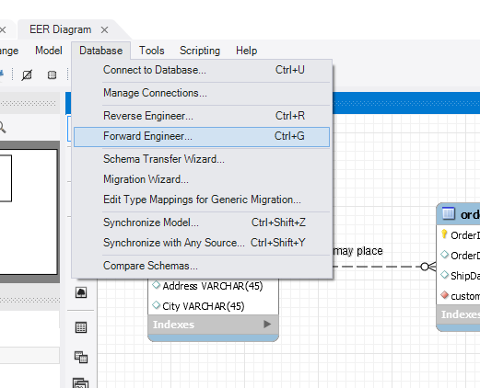

Pick the default options from the next two screens.

You should get this message.

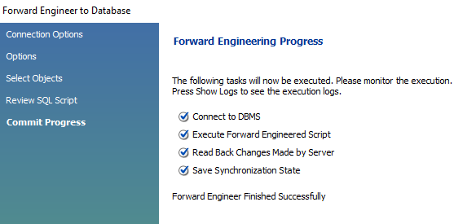

Now click the Home screen, and then click the Server Instance (first option from the top) and connect to the server.

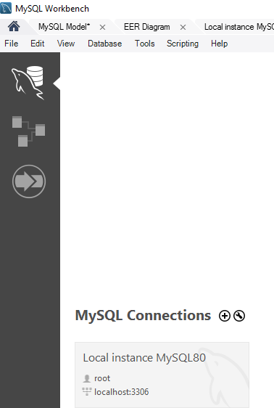

The newly created schema **Lab5** should appear in the schemas list (refresh it) and expand to view a list of the 4 tables in this schema

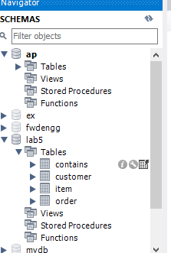

**Adding Data to the tables**

Click on the table icon in front of the table name in this view, and open the table and insert data in each table

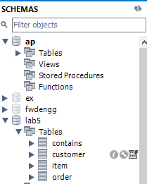

**Add data in the Customer table**

Click on the table icon in front of the customer table and open it in the following (data entry) format

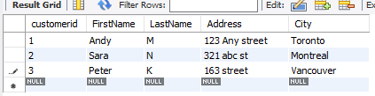

Now add data in the other three tables.

Please remember to add data in primary table(s) first before adding data to related tables.

For example, you cannot add data in the **order** table before the **customer** table. The Order table has a column **Customer_CustomerId** (the foreign key) and the value you enter here for a customers’ Id should be a valid value in the Customer table (1,2,3 in this case).

For this example the sequence in which you can add data in tables is: **Customer, Order, Item, Contains**

**LAB Exercises**

**Create Physical Data Models for the following three cases, Forward Engineer these models to create a schema (use a different schema name for each example) with all tables in it. Insert Five (5) records per table.**

1. **ABC Company** is a small online retailer. ABC would like to store data about its customers, orders, items, couriers. Each customer may place multiple orders. An item may be part of many orders and an order typically contains multiple items. Each order is shipped via one of the couriers (parcel companies) and ABC Inc. has contracts with several couriers for shipping its customer orders. **[schema name: Lab5a]**



1. **ABC College** has many departments and each department offer courses and some popular courses have many course sections. Each Faculty member belongs to a particular department and may teach more than one course sections of a course, but in some semesters a faculty member may not teach any. Each course section must have at least one faculty number teaching it, but sometimes multiple faculty members teach course sections. Furthermore, to make sure that all course sections are similar, one faculty member is assigned as course coordinator to oversee the course, and each faculty member may coordinate many courses. Students may enroll in many course sections and receive a grade at the end of the term for every course that they have enrolled in. **[schema name: Lab5b]**



1. **ABC Law firm** has thirty lawyers (Attorneys) working in it. Clients hire an Attorney for their legal cases. Sometimes a case is filed collectively (class action) by a number of clients. Some cases have a team of attorneys assigned to them by ABC’s Manager. Each case is heard by one and only one court but a single court can hear many cases from this law firm. Each court has one or many judges assigned to it but one judge works only in one court. Normally one judge hears a particular case. Sometimes for bigger cases, a bench of judges are assigned to the case by the presiding judge for that court. The cases remain active until the court passes the final judgement on it. [**Schema name: Lab5b]**

